EXP 1: Create a topology consisting of 2 or more n devices connected with the help of hub and switch and stimulate.

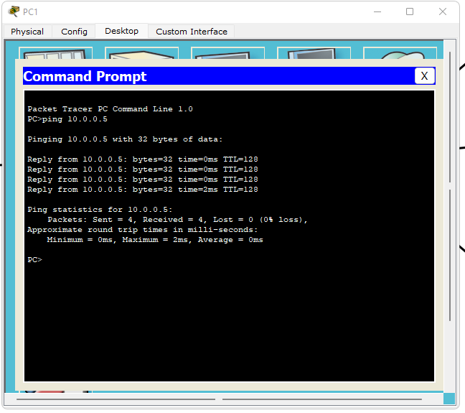

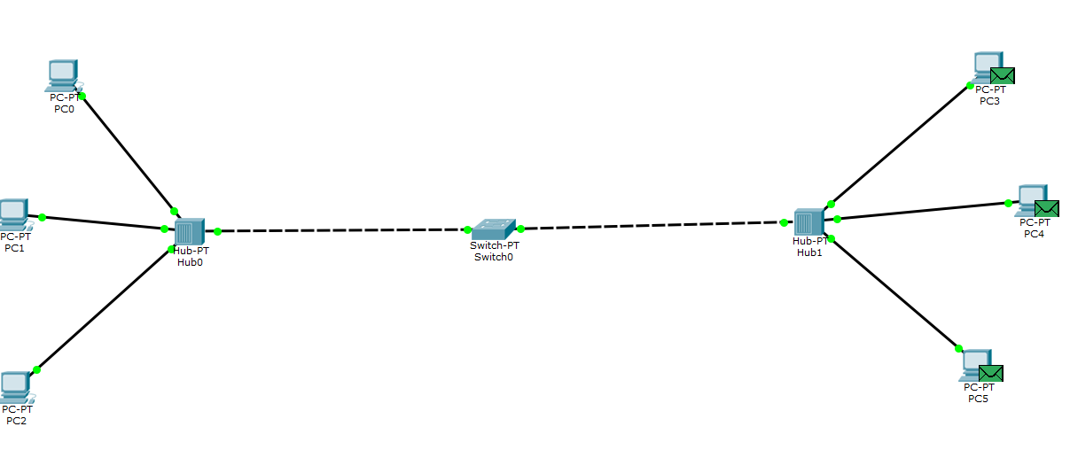

OUTCOME

HUB:

1. Using the hub connection is established immediately
2. It broadcasts data packets to all the outputs interface except incoming interface

Switch:

1. The switch takes approx. 20 sec to generate connection.
2. At first it broadcasts the data packets to all the end device to form a switching table , then it sends the packet only to the destination device.

The outcome of this network topology is a scalable and efficient network infrastructure that allows for seamless communication between multiple devices. By utilizing hubs and switches, the network can effectively manage the flow of data and accommodate the connectivity needs of a large number of devices.